 | 12.1.43 Editors - Geometry Nodes Editor - Header - Add Menu - Hair - Deformation
Table of content
Detailed table of content 1
Add menu - Hair - Deformation 3
Blend Hair Curves 4
Displace Hair Curves 5
Frizz Hair Curves 6
Hair Curves Noise 7
Roll Hair Curves 8
Rotate Hair Curves 9
Shrinkwrap Hair Curves 10
Smooth Hair Curves 10
Straighten Hair Curves 11
Trim Hair Curves 12

Detailed table of content
Table of content
Detailed table of content 1
Add menu - Hair - Deformation 3
Blend Hair Curves 4
Input 4
Geometry 4
Factor 4
Blend Radius 4
Blend Neighbours 4
Preserve Length 4
Output 4
Geometry 4
Displace Hair Curves 5
Input 5
Geometry 5
Factor 5
Shape 5
Object 5
Displace Vector 5
Surface Object 5
Surface Geometry 5
Surface UV Map 5
Surface Normal Displacement 5
Output 5
Geometry 5
Frizz Hair Curves 6
Input 6
Geometry 6
Cumulative Offset 6
Factor 6
Distance 6
Shape 6
Seed 6
Preserve Length 6
Output 6
Geometry 6
Offset Vector 6
Hair Curves Noise 7
Input 7
Geometry 7
Cumulative Offset 7
Factor 7
Distance 7
Shape 7
Scale 7
Scale along Curve 7
Offset per curve 7
Seed 7
Preserve Length 7
Output 7
Geometry 7
Offset Vector 7
Roll Hair Curves 8
Input 8
Factor 8
Subdivision 8
Variation Level 8
Roll Lenght 8
Roll Radius 8
Roll Depth 8
Roll Taper 8
Retain Overall Shape 8
Roll Direction 8
Random Orientation 8
Seed 8
Preserve Length 8
Output 9
Geometry 9
Rotate Hair Curves 9
Input 9
Geometry 9
Factor 9
Axis 9
Angle 9
Random Off 9
Lock Ends 9
Seed 9
Output 9
Geometry 9
Shrinkwrap Hair Curves 10
Input 10
Geometry 10
Surface 10
Surface Object 10
Factor 10
Offset Distance 10
Above Surface 10
Smoothing Steps 10
Lock Roots 10
Output 10
Geometry 10
Smooth Hair Curves 10
Input 10
Geometry 10
Amount 11
Shape 11
Iterations 11
Weight 11
Lock Tip 11
Preserve Length 11
Output 11
Geometry 11
Straighten Hair Curves 11
Input 11
Geometry 11
Amount 11
Shape 11
Preserve Length 11
Output 12
Geometry 12
Trim Hair Curves 12
Input 12
Geometry 12
Scale Uniform 12
Length Factor 12
Replace Length 12
Length 12
Mask 12
Random Offset 12
Pin at parameter 12
Seed 12

Add menu - Hair - Deformation
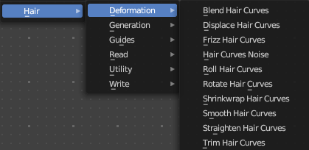
Hair nodes are, different from the other nodes in the add menu, groups of nodes. And not single nodes. You can enter the node tree by clicking at the icon up right. Tab to leave the node tree. And you can of course also edit the node tree.




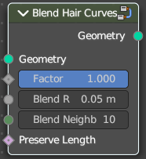
Blend Hair Curves
Blends the shape between multiple hair curves in a certain radius together.

Input

Geometry
The input geometry.

Factor
Factor to blend overall effect.

Blend Radius
Radius to select neighbors for blending.

Blend Neighbours
Amount of neighbors used for blending.

Preserve Length
Preserve the length of each curve during deformation.

Output

Geometry
The output geometry.

Displace Hair Curves
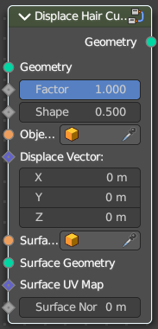
Displaces hair curves by a vector based on options.

Input

Geometry
The input geometry.

Factor
Factor to blend overall effect.

Shape
Shape of the influence along curves. 0 means constant. 0.5 means linear.

Object
The object to determine the displacement space.

Displace Vector
The vector for the displacement.

Surface Object
Surface object used to sample the normal for displacement.

Surface Geometry
Surface geometry used to sample the normal for displacement.

Surface UV Map
Surface UV Map used to sample the normal for displacement.

Surface Normal Displacement
Amount of displacement along the surface normals.

Output

Geometry
The output geometry.

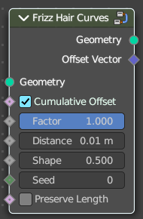
Frizz Hair Curves
Deforms hair curves using a random vector per point to frizz them.

Input

Geometry
The input geometry.

Cumulative Offset
Apply offset cumulatively.

Factor
Factor to blend overall effect.

Distance
Overall distance factor for the deformation.

Shape
Shape of the influence along curves. 0 means constant. 0.5 means linear.

Seed
Random seed for the operation.

Preserve Length
Preserve the length of each curve during deformation.

Output

Geometry
The output geometry.

Offset Vector
The vector by which each point was offset during deformation.

Hair Curves Noise
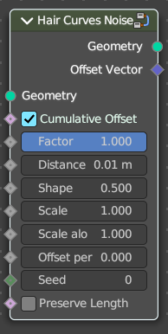
Deforms hair curves using noise texture.

Input

Geometry
The input geometry.

Cumulative Offset
Apply offset cumulatively.

Factor
Factor to blend overall effect.

Distance
Overall distance factor for the deformation.

Shape
Shape of the influence along curves. 0 means constant. 0.5 means linear.

Scale
Scale of the noise texture by root position.

Scale along Curve
Scale of the noise texture along the curve.

Offset per curve

Seed
Random seed for the operation.

Preserve Length
Preserve the length of each curve during deformation.

Output

Geometry
The output geometry.

Offset Vector
The vector by which each point was offset during deformation.

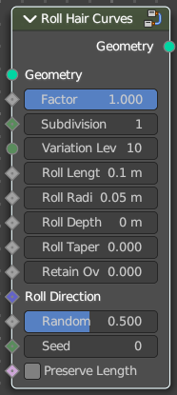
Roll Hair Curves
Rolls up hair curves, starting from their tips.

Input

Factor
Factor to blend overall effect.

Subdivision
Subdivision level applied before deformation.

Variation Level
Level of smoothing on the roll path to include shape variation.

Roll Lenght
Length of each curve to be rolled

Roll Radius
Radius of the rolls.

Roll Depth
Depth offset of the rolls.

Roll Taper
Taper of the roll.

Retain Overall Shape
Offset the roll along the original curve to retain shape.

Roll Direction
The axis around each curve is rolled.

Random Orientation
Amount of randomization of the direction of the roll.

Seed
Random seed for the operation.

Preserve Length
Preserve the length of each curve during deformation.

Output

Geometry
The output geometry.

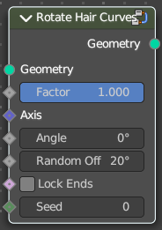
Rotate Hair Curves
Rotates each hair curve around an axis.

Input

Geometry
The input geometry.

Factor
Factor to blend overall effect.

Axis
Rotation Axis. The default is tangent at root.

Angle
Angle of rotation

Random Off
Random offset to the rotation angle per curve.

Lock Ends
Lock rotation to the axis between the curve ends.

Seed
Random seed for the operation.

Output

Geometry
The output geometry.

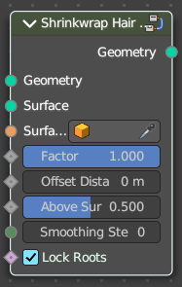
Shrinkwrap Hair Curves
Shrinkwrap hair curves to a mesh surface from below and optionally from above.

Input

Geometry
The input geometry.

Surface
Surface geometry used for shrinkwrap.

Surface Object
A surface object used for shrinkwrap.

Factor
Factor to blend overall effect.

Offset Distance
Distance of the surface to shrinkwrap.

Above Surface
Blend shrinkwrap for points above the surface.

Smoothing Steps
The steps of Smoothing applied after shrinkwrap.

Lock Roots
Lock the position of root points.

Output

Geometry
The output geometry.

Smooth Hair Curves
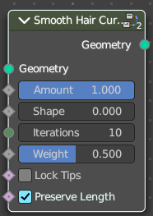
Smoothes the shape of hair curves.

Input

Geometry
The input geometry.

Amount
Amount of smoothing.

Shape
Shape of the influence along curves. 0 means constant. 0.5 means linear.

Iterations
Amount of smoothing steps.

Weight
Smoothing weight.

Lock Tip
Lock the position of tip points.

Preserve Length
Preserve the length of each curve during deformation.

Output

Geometry
The output geometry.

Straighten Hair Curves
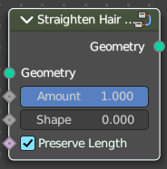
Straighten hair curves between root and tip.

Input

Geometry
The input geometry.

Amount
Amount of smoothing.

Shape
Shape of the influence along curves. 0 means constant. 0.5 means linear.

Preserve Length
Preserve the length of each curve during deformation.

Output

Geometry
The output geometry.

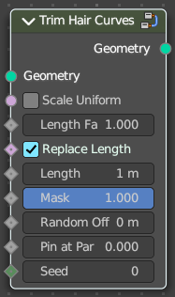
Trim Hair Curves
Trims or scales hair curves to a certain length.

Input

Geometry
The input geometry.

Scale Uniform
Scale each curve uniformly to reach the target length.

Length Factor
Multiply the original length by a factor

Replace Length
Use the length input to fully replace the original length.

Length
Target length for the operation.

Mask
Mask to blend overall effect.

Random Offset
Trim hair curves randomly up to a certain amount.

Pin at parameter
Pin each curve at a certain point for the operation.

Seed
Random seed for the operation.

Output

Geometry
The output geometry.

